Website corrections points
- Digital Nest Solution logo should be Large size and should come to corner left
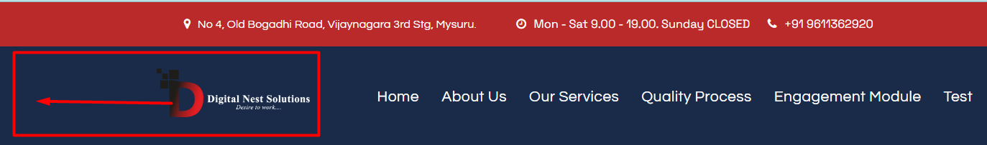
- Background color of ribbon should be changed to White from blue and text color to red

- Need to be highlighted after selection, when we are on that page
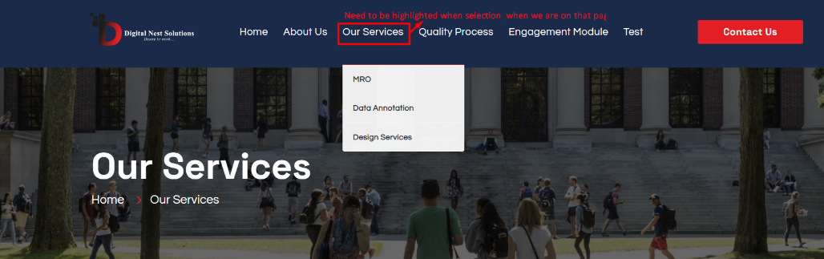
- Need to get the dropdown for all types of annotation after selecting data annotation and also same for Design services
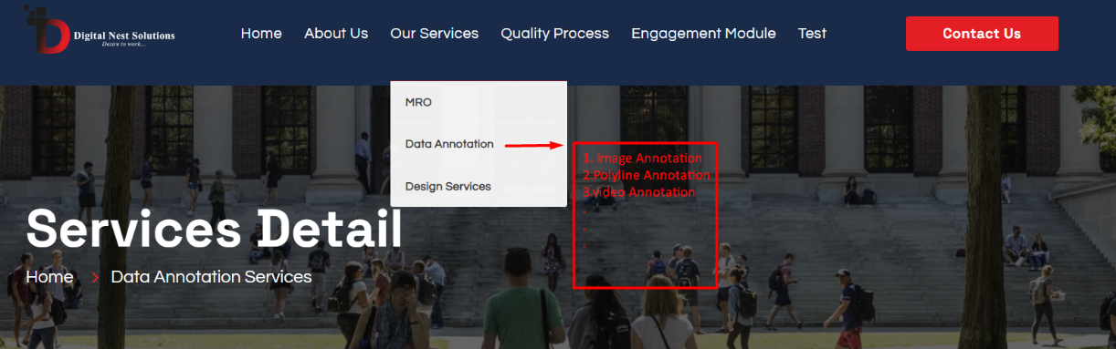
- When we select our services, page should be show under our services not home
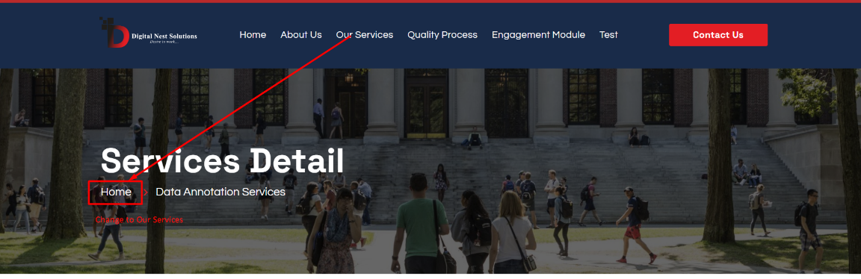

- Quality process and Engagement models need to get updated
spelling error in engagement model ( Module – Model )
- Need to add email ID at marked place
- Need to update the image for Polyline annotation

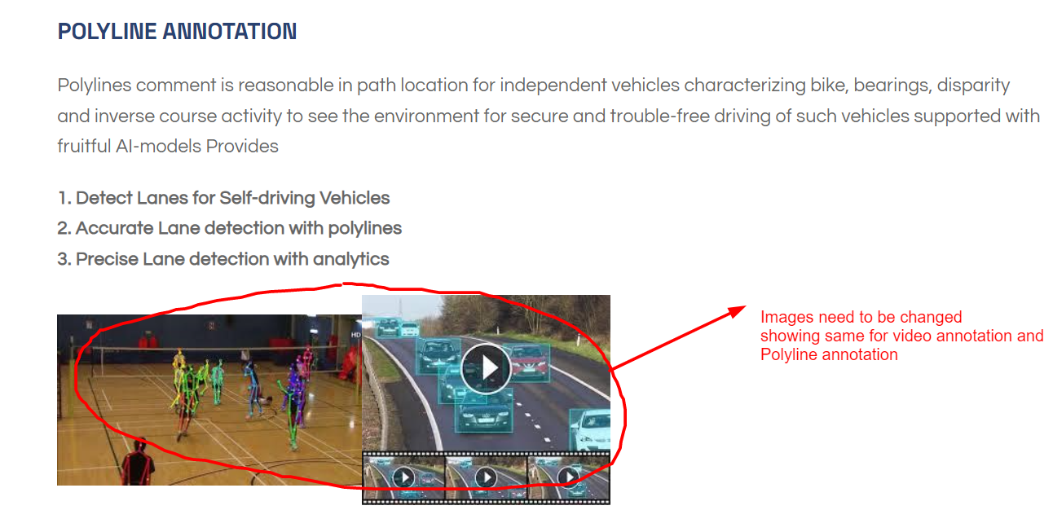

- Related Theme should come to the interface after selecting the topic
(Below image is coming for every topic we select)
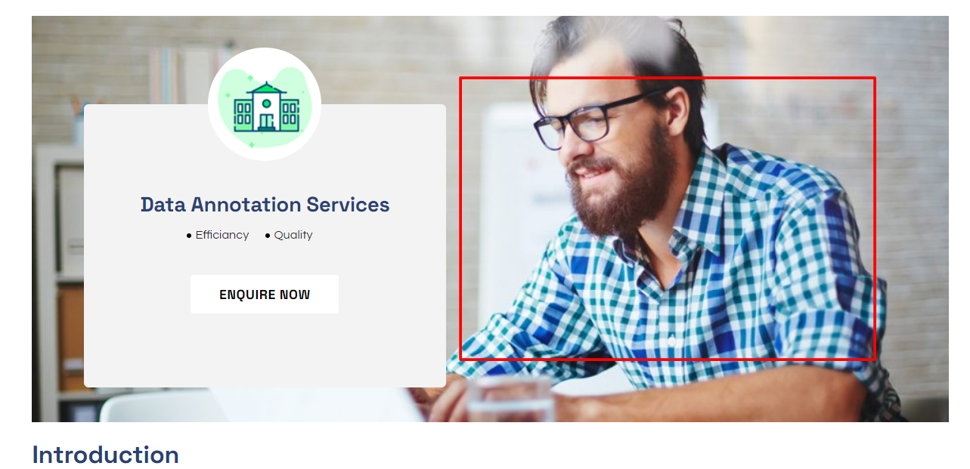
- Spelling needs to be updated – Efficiency
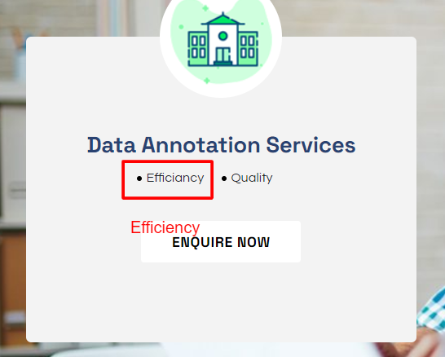
- What we offer and Material Master Data management is not required in the
Remove the marked headlines
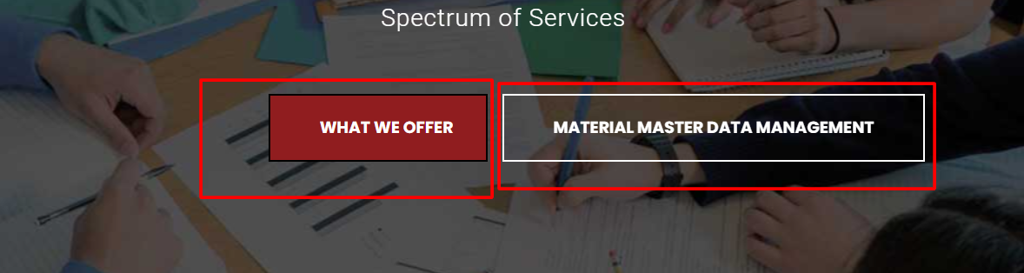
- Need to update Engagement Models completely by using provided data
Marked info is missing
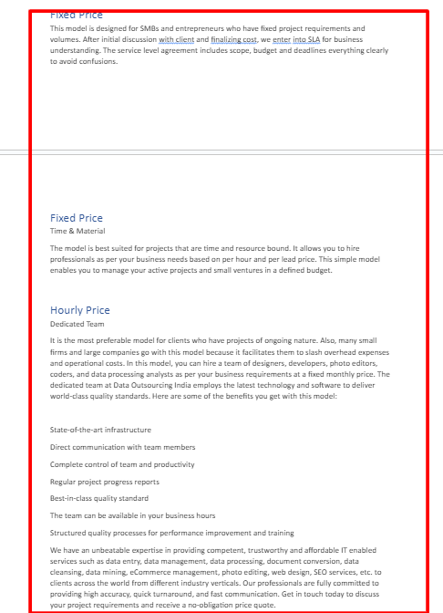
- Data annotation, PV design, Interior design are showing under MRO
They should not come under MRO
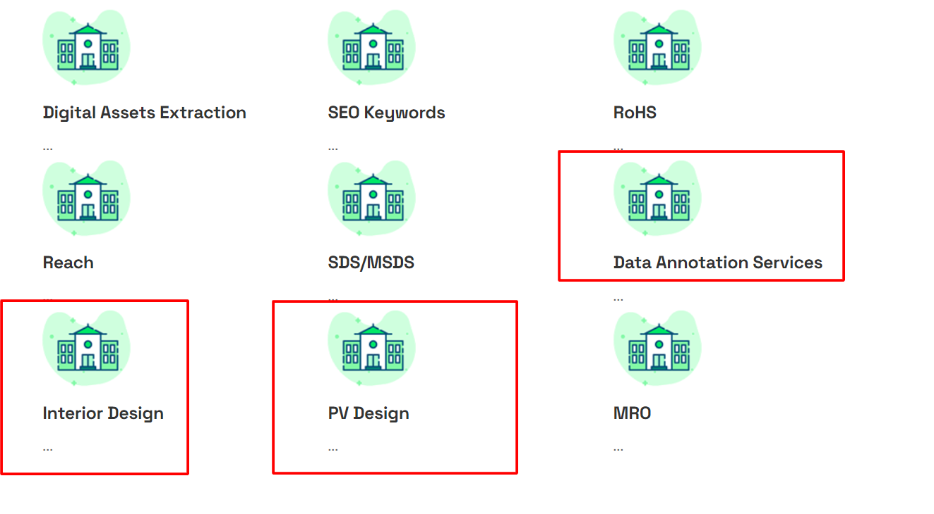
- We need to add a G- Meet Link in schedule an appointment
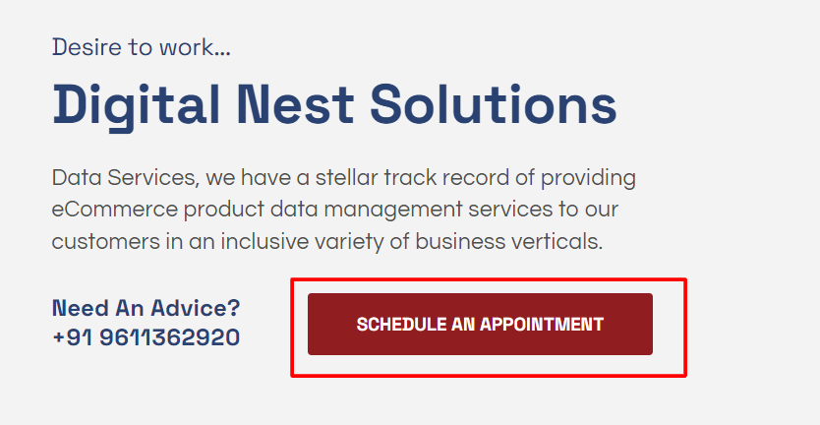

- Need to remove marked MRO details in Home Page
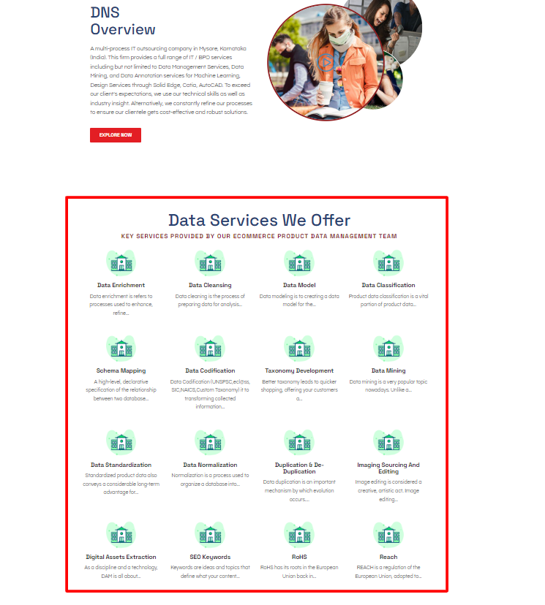
- We should add in Home page about our achievements and expertise
as shown in image
Below example should be added to each services
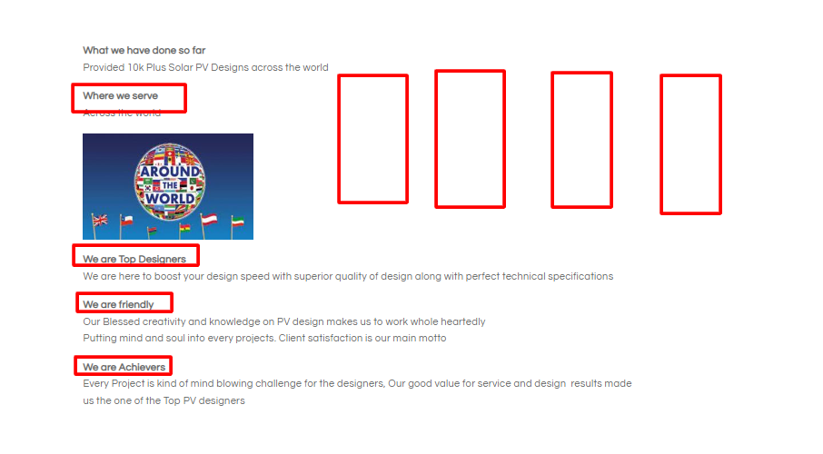
- Remove the useful links option at the bottom and Place DNS Logo and DNS office address
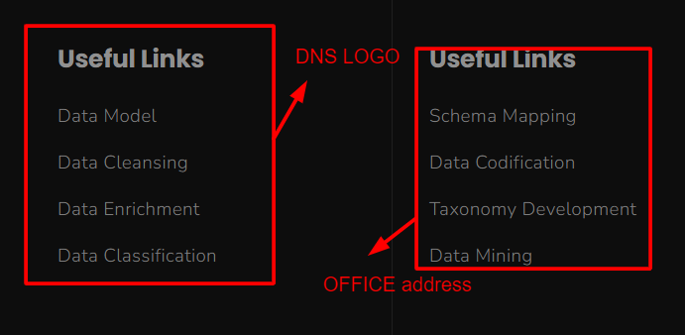
- DNS Overview should come under ABOUT US
